Circuit Analysis (Lab4)
Experiment 4: Implementation of Basic Parallel Circuit

Name: Sania Khan
Registration No: Sania Khan (2025-CE-14)

CLO2  CLO3 | Use with identification the circuit components, breadboards, multimeters, power supplies, signal generators, and oscilloscopes.  Make measurements in their own constructed electric circuits.
Psychomotor/Affective | Level1  (1) | Level2 (2-3) | Level3 (4-5) | Level4 (6-7)
Report Marks (3) |  |  | Total marks  (10)
________________________________________________________________________________

Objectives: To make measurements in your own constructed parallel circuits.
Equipment required:
Power Supply, Breadboard, Connecting wires, Resistances, Multimeter.

How to make resistance measurements
Resistance is measured with the circuit’s power turned off. The ohmmeter sends its own current through the unknown resistance and then measures that current to provide a resistance value readout.

Resistance measurement procedures
Follow the steps below to measure resistance:
- Turn off the power to the circuit. Remove or isolate the component to be tested.
- Plug the test probes into the appropriate probe jacks. Note that the jacks used may be the same ones used to measure volts.
- Select the ohms function by turning the function switch to ohms. Start with the lowest setting.
- Touch the probes together to check the leads, connections and battery life. The meter should display zero or a very small amount of resistance for the test leads. With the leads apart, the meter should display OL or I, depending on the manufacturer.
- Connect the tips of the probes across the break in the component or portion of the circuit for which you want to determine resistance. If you get an OL (over limit), move to the next level.
- View the reading on the display unit. Be sure to note the unit of measurement.
- After all the resistance readings are complete, turn the DMM off to prevent the battery from draining
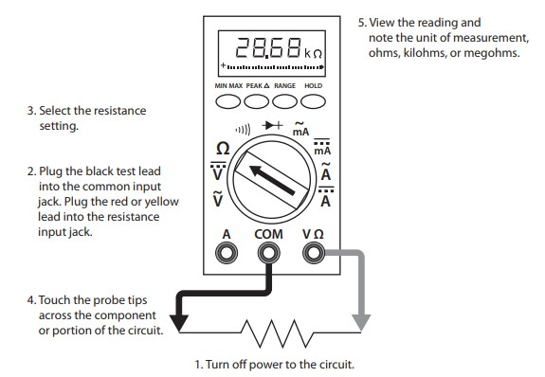
Figure 1 Using a DMM to measure resistance

How to make voltage measurements
Voltage measurements are very easy to make with a DMM. On meters with manual range selection, start with a value one setting higher than expected. An auto range DMM will automatically select the range based on the voltage present. Figure 4 shows the process.
Note:
1/ 1000 V=1mV
1000 V=1kV
Follow these steps to measure voltage:
- Select the DC or AC volts function by turning the function switch to DC or AC volts.
- Plug the test probes into the appropriate probe jacks.
- Connect the tips of the probes across the source or load.
- View the reading on the display unit. Be sure to note the unit of measurement. If you are testing DC voltage and a negative sign appears in the display, the polarity of your probes is incorrect and needs to be reversed.
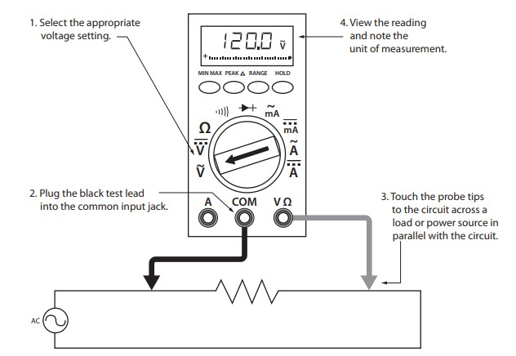
Figure 2 Using a DMM to measure voltage

How to make Current measurements
Follow the steps below to measure current:
- Turn off the power to the circuit that will be measured.
- Open the circuit by disconnecting or unsoldering a connection at a point where you wish to measure current.
- Select the DC or AC amps function by turning the function switch to DC or AC amps.
- Plug the test probes into the appropriate probe jacks. Note that the jacks used may not be the same ones used to measure volts.
- Connect the tips of the probes across the break in the circuit so that the current to be measured flows through the meter. Note that this is a series connection. Never connect the ammeter in parallel with the source or load, as this will cause a short circuit and damage the meter.
- Turn the circuit power back on.
- View the reading on the display unit. Be sure to note the unit of measurement.
- Switch power off and disconnect meter leads from the circuit.
- If testing is finished at this test point, restore the circuit by reclosing the connection. When current measurements are complete, turn the function switch to the OFF position and remove the test leads.
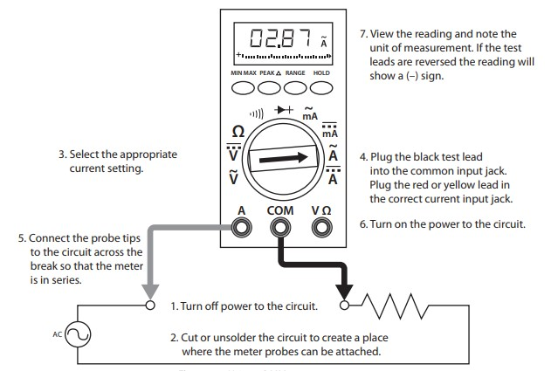

Figure 3 Using a DMM to measure current
Lab Tasks:
      - Measure the current across R1, R2, R3 and Voltage between node 2 and 7.
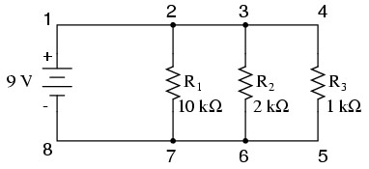

Practical Values:

R1 Current

R2 Current

R3 Current

Voltage

Theoretical Values:

R1 Current

R2 Current

R3 Current

Voltage

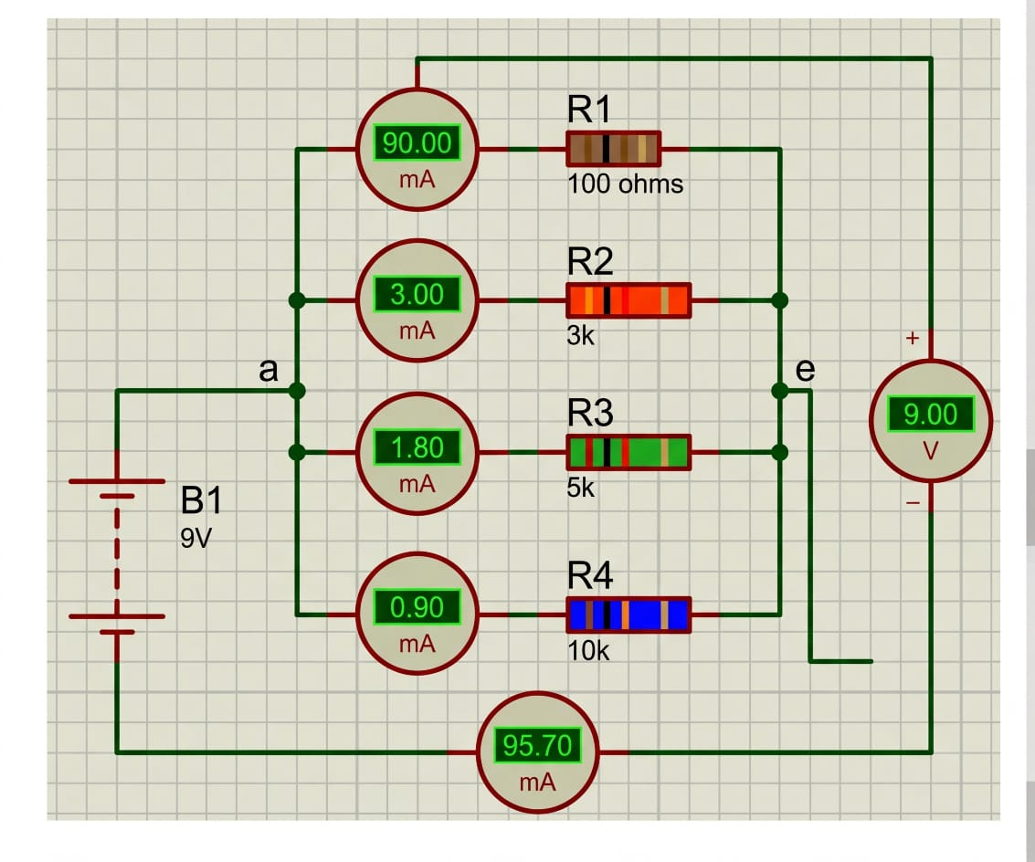
This circuit demonstrates current branching in a parallel configuration.
- Component Selection:
In ‘Component Mode’, click the ‘P’ button.
Search for and select: RES (Resistor) and BATTERY (B1).
Place one BATTERY and four RES components.
- Adding Instruments:
Go to the ‘Instrument’ tab.
Select and place five DC AMMETERS (one for each branch and one for the total current).
Select and place one DC VOLTMETER.
Note: To see the values in mA as shown in your image, right-click each Ammeter, go to Edit Properties, and change the Display Range to Milliamps.
- Setting Values:
Set B1 to 9V.
Set resistor values: R1 = 100 ohms, R2 = 3k, R3 = 5k, and R4 = 10k.
- Wiring Parallel Branches (Point ‘a’ to ‘e’):
Connect the positive terminal of B1 to a common node (Point a).
From node a, create four parallel branches. In each branch, connect a DC Ammeter in series with its respective resistor (R1, R2, R3, R4).
Connect the exit end of all four resistors to a common return node (Point e).
- Finalizing Connections:
Place the fifth DC Ammeter between the return node e and the negative terminal of B1 to measure the total current (95.70\text{ mA}).
Connect the DC Voltmeter in parallel across the entire group (from node a to node e) to measure the source voltage (9.00\text{ V}).

      - Measure the current across R1, R2, R3 and Voltage between node a and e.
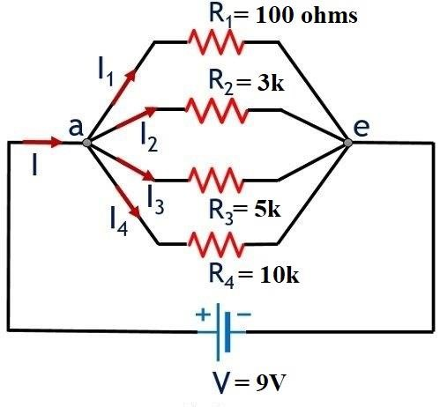
Practical Values:

R1 Current

R2 Current

R3 Current

R4 Current

Voltage

Theoretical Values:

R1 Current | R2 Current | R3 Current | R4 Current | Voltage

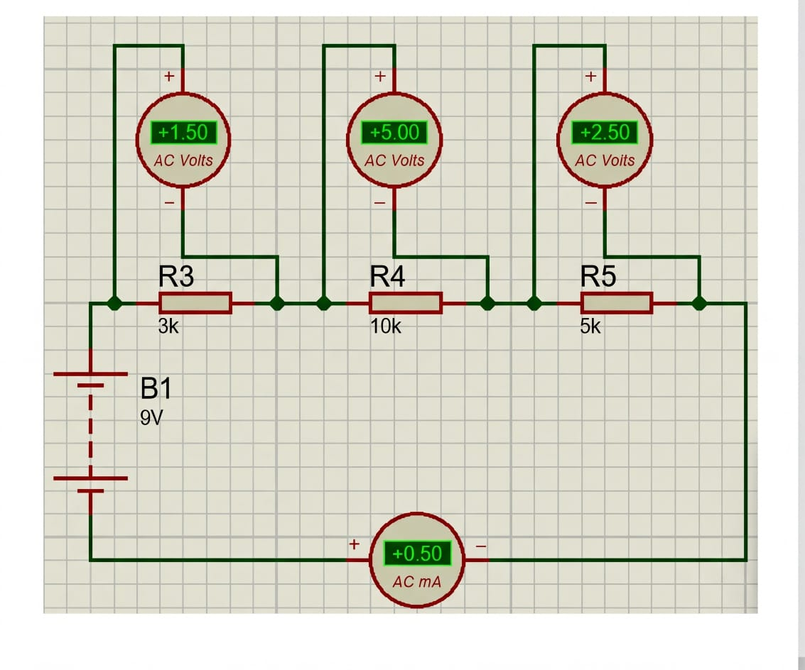

This circuit demonstrates voltage division across resistors in a single loop.
- Component Selection:
In ‘Component Mode’, click the ‘P’ button.
Search for and select: RES (Resistor) and BATTERY (Multi-cell DC source).
Place one BATTERY (B1) and three RES (R3, R4, R5) components on the sheet.
- Adding Instruments:
Go to the ‘Instrument’ tab.
Select and place three AC VOLTMETERS and one AC AMMETER.
- Setting Values:
Right-click the battery and set the voltage to 9V.
Set the resistor values to: R3 = 3k, R4 = 10k, and R5 = 5k.
- Wiring the Loop:
Connect the positive terminal of B1 to the input of R3.
Connect R3 to R4, and R4 to R5 in a series line.
Connect the AC AMMETER in series between the end of R5 and the negative terminal of the battery to close the circuit.
- Placing Voltmeters:
Connect one AC Voltmeter in parallel across R3.
Connect the second AC Voltmeter in parallel across R4.
Connect the third AC Voltmeter in parallel across R5.

Post Lab Questions:
    - Why is the value of voltage across each resistor in parallel circuit same?

In a parallel circuit, the voltage across each resistor is the same because all resistors are connected directly across the same two points (nodes) of the power source, so each one experiences the full potential difference of the source regardless of the current flowing through it.
2.

    - When parallel resistors are of three different values, which has the greatest power loss?

When parallel resistors have different values, the resistor with the smallest resistance experiences the greatest power loss and with the same voltage across all resistors, a smaller resistance allows more current to flow, converting more electrical energy into heat.

    - How the current across any branch of a parallel circuit varies?

The current in each branch of a parallel circuit varies inversely with the resistance of that branch: lower-resistance branches carry more current, higher-resistance branches carry less, while the voltage across all branches remains the same; the total current from the source is simply the sum of the currents through all branches.

4. What happens to total resistance in a circuit with parallel resistors if one of them opens (i.e., removed)?

If one resistor in a parallel circuit is removed (opens), the total resistance of the circuit increases because there is now one fewer path for current to flow, reducing the combined conductance and causing less total current to flow through the remaining branches.

3.

